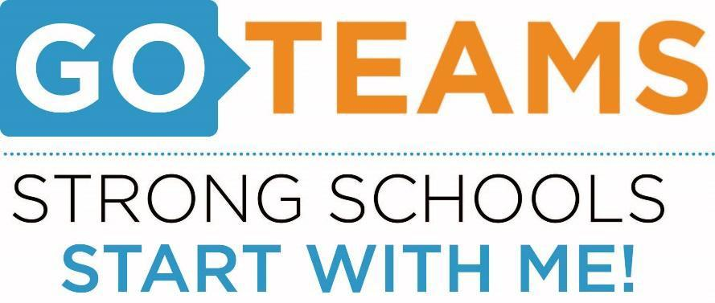

Meeting Notice

School Name | Date | Time | Location
Cleveland Avenue Elementary | November 17, 2016 | 5:00pm | Main Conference Room

Action Items:

Complete GO Team Certification
- Determine Public Comment Format
- Draft CAE Strategic Plan

The meeting agenda will include the following topics:
- Go Team Certification
- CAE Strategic Plan

Discussion Items:

Information Items:

Date of Notice:
Name of Person Preparing Notice:
Telephone number of person preparing Notice:

